Clinical Safety Case Report – Palliative and End of Life Care Information Standard

Professional Record Standards Body

Document filename: Clinical Safety Case Report – Palliative and End of Life Care Information Standard
Directorate / Programme |  |  | Project | Palliative and End of Life Care Information Standard
Document Reference
Director |  |  | Status | Final
Owner | Steve Bentley |  | Version | v1.4
Authors |  | Sharon Hanley  Steve Bentley | Version issue date | 03/07/2025

Published January 2023
Document Management
Revision History
Version | Date | Summary of Changes
v0.1 | 01/06/2022 | First Draft
v0.2 | 09/06/2022 | Second Draft
v0.3 | 05/07/2022 | Third Draft
v0.4 | 10/11/2022 | Final Draft
v1.0 | 02/12/2022 | Final Version
v1.1 | 16/12/2022 | Updated following NHS Digital Feedback
v1.2 | 03/01/2023 | Updated following further updates from NHS Digital
v1.3 | 24/01/2023 | Final following further updates from NHS Digital
v1.4 | 03/07/2025 | Updated following identification of a new hazard (Generic Hazard 10) and including minor formatting changes and error correction. Update of Generic Hazard 4.

Reviewers
This document must be reviewed by the following people:
Reviewer name | Title / Responsibility | Date | Version
Kath Lambert | PEoLC Information Standard Clinical Lead, Consultant in Palliative Medicine, Harrogate and District NHS Foundation Trust | 24/01/2023 | 0.3, 0.4,1.0,1.1, 1.2
Emma Davis | GP, Clinical Lead - HIOW Shared Care Record, Clinical Safety Officer | 16/12/2022 | 0.3, 0.4,1.0,1.1.1.2
Helene Feger | PRSB Director of strategy, communications, and engagement | 16/12/2022 | 0.3, 0.4,1.0,1.1,1.2
NHS Digital Clinical Safety Group | NHS Digital Clinical Safety Officers & Engineers | 11/01/2023 | 1.2
Steve Bentley | PRSB Clinical Safety Officer | 03/07/2025 | 1.4

Approved by
This document must be approved by the following people:
Name | Title | Date | Version
PRSB | Assurance Committee |  | 1.3
Kath Lambert | PEoLC Information Standard Clinical Lead |  | 1.3
Emma Davis | Clinical Safety Officer |  | 1.3
NHS Digital Clinical Safety Group | NHS Digital Clinical Safety Officers & Engineers |  | 1.3
Steve Bentley | PRSB Clinical Safety Officer | 03/07/2025 | 1.4

Related Documents
These documents provide additional information and are specifically referenced within this document.
Ref | Doc Reference Number | Title | Version | Status
1 | DCB 0129 | Clinical Risk Management: its Application in the Manufacture of Health IT Systems - Specification | 4.2 | Approved
2 | DCB 0160 | Clinical Risk Management: its Application in the Deployment and Use of Health IT Systems - Specification | 3.2 | Approved
3 | Appendix B | PEoLC Information Standard | v1.11 | Draft
4 | Appendix C | Palliative and End of Life Care Information Standard – Final Report | v1.01 | Draft
5 | Appendix D | PEoLC Survey Report | v1.0
6 | Appendix E | General implementation guidance for ALL PRSB standards  (Detailed guidance, specific to the sections and elements of the standard, are included in the standard) | v1.5 | Approved
7 | Appendix F | Link to the PRSB PEoLC Information Standard web page |  | Draft
8 | Appendix G | Risk Scoring Matrix
9 | Appendix H | PEoLC Standard Hazard Log | v1.4

Contents
Executive summary and safety statement 5
1. Introduction 6
In scope: 7
Out of scope 8
2. System Definition / Overview 8
3. Clinical Risk Management System 8
4. Clinical Risk Analysis 10
5. Clinical Risk Evaluation 11
Clinical Risk Control 11
Hazard Log 22
6. Test Issues 23
7. Summary Safety Statement 23
8. Quality Assurance and Document Approval 23
9. Configuration Control / Management 23
10. Appendices 24
Appendix A – Palliative and End of Life Care Working Group Members 24
Appendix B - PEoLC Information Standard 24
https://theprsb.org/standards/palliativeandendoflifecare/ 24
Appendix C – PEoLC Information Standard – Final Report 24
https://theprsb.org/standards/palliativeandendoflifecare/ 24
Appendix D - PEoLC Survey Report 24
https://theprsb.org/standards/palliativeandendoflifecare/ 24
Appendix E - General implementation guidance for ALL PRSB standards 24
Appendix F - Link to the PRSB PEoLC Information Standard web page 25
Appendix G – Risk scoring Matrix 25

Executive summary and safety statement
This document provides a clinical safety case for the Palliative and End of Life Care (PEoLC) Information Standard project. The project has delivered information models and implementation guidance which will be used by IT suppliers and healthcare organisations to develop technical standards for structuring, coding, and sharing PEoLC information, with a view to incorporating it into standard clinical IT contracts to facilitate better access and interoperability.

Seventeen potential hazards were originally identified of which 9 were classed as generic hazards and 8 as specific to PEoLC. Of the 17 hazards 6 were reduced (1 hazard reduced from 4 to 3 (this hazard, related to the recording and display of sex and gender data items in a person’s clinical record, was subsequently reevaluated as a result of updates to the standard and scored 3 reduced to 2 on mitigation), 5 hazards reduced from 3 to 2) and 11 hazards stayed the same. A new generic hazard ‘Legacy data not managed correctly’ was created at a later date and mitigated from 3 to 2. A summary of all hazards with an initial risk rating of 3 or above can be found in section 5 – Clinical Risk Evaluation.

The mitigated hazards include information that should be addressed by implementers. All hazards were identified through the consultation steps carried out to develop these standards and subsequent support and maintenance. The consultations consisted of one multidisciplinary workshop held on the 12th Jan 2022, clinical risk discussions during project meetings, online survey, review of draft information models and implementation guidance (by clinical informaticians and system suppliers) and an expert user group meeting. These workshops, surveys and communications included patient representatives as well as professionals working in end-of-life care, NHS Digital terminologists, and system suppliers. Suppliers involved in the project included Black Pear, Graphnet, Cerner, Nourish Care, EveryLIFE technologies as well as associations CASPA and TechUK. Details of the workshops and the consultation findings can be found in the PEoLC Information Standard Final Report (see appendix C)

At each step of the consultation hazards were identified, reviewed and mitigations/actions considered. Nevertheless, some risk is inherent in the standards, but most has been:

- mitigated by the development of the standards

- or the residual risk has been transferred (with guidance) to the implementers.

Certain hazards were deemed system implementation matters. The hazard log (embedded within this document) provides guidance for system developers and implementers. It is important that this guidance in relation to these hazards become requirements for implementation.

N.B: This clinical safety report is necessarily limited in its scope because it is neither directly related to software development nor to deployment. Suppliers developing software to implement these standards will therefore still be expected fully to apply DCB0129. Organisations involved in the deployment of such software will still be expected fully to apply DCB0160.

The report has been overseen by the Clinical Safety Officer (CSO) for the project; Emma Davis (GP, Clinical Lead - HIOW Shared Care Record, Clinical Safety Office) and later updated by Steve Bentley (CSO).

Introduction
This Clinical Safety Case Report documents the scope, functionality, and clinical risk management activities for a new standard for the Palliative and End of Life Care information standard. It is intended to support vendors and developers as well as healthcare organisations implementing the standard in clinical IT systems.

The diagram below illustrates the information in a person’s full health and care record. The Core Information Standard defines the information in a person’s full record, for sharing as needed. The Personalised Care & Support Plan standard defines information in the record that is for care planning. The Palliative and End of Life information standard defines information to support care relevant at the end of life.

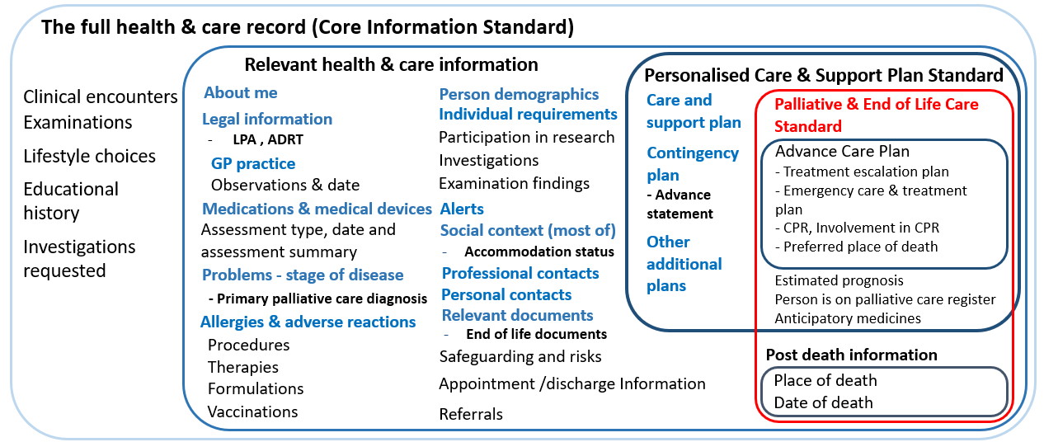

The full health & care record is defined by the Core Information Standard, includes information that may be relevant to personalised care and support planning, including advance care planning for people with palliative and end of life care needs.
Relevant health & care information is essential information to support personalised care and support planning, including advance care planning, for people with palliative and end of life care needs. A care plan can’t be created/updated without being aware of this information. This information may be used for non-care planning purposes.
Personalised care and support information is essential to personalised care and support planning and elements can be used to inform advance care planning conversations for people with palliative and end of life care needs.
Information that is unique/specific to palliative and end of life care plans: The Palliative and End of Life Care Information Standard sets out what information is needed to support the care of people who are approaching the end of life.

The PEoLC Information Standard v0.2 (current version 1.11 [Ref. 3]) has been co-produced with a wide range of stakeholders; NHS E/I, professionals working in palliative and end of life care, patients/ carers, regional Children and Young People’s Palliative Care Networks and the Children and Young People’s Advance Care Planning network and system suppliers. Suppliers involved in the project included Black Pear, Graphnet, Cerner, Nourish Care, EveryLIFE technologies as well as associations CASPA and TechUK.

The following approach was taken in the development of the PEoLC standard

      - A discovery phase - June – Dec 2020. An initial review of barriers to Electronic Palliative Care Coordination Systems (EPaCCS) and end of life care information sharing. Identifying areas of focus and initial mapping of local data sets and specifications with national standards. A webinar was held on 11th Dec 2020.
      - A review phase – Reviewing the draft standard and discussion of key requirements with a diverse range of stakeholders.
- An online survey with Compassion in Dying was conducted in February 2021, to understand what would give people more confidence in their end-of-life care information.
- In addition, PRSB with Together for Short Lives interviewed five parents of children and young people with life limiting conditions, and one young person.
- Early drafts of the standard and supporting materials were made available to key stakeholders for review and comment over a six-week period in May – June 2021 and five virtual drop-in sessions were held to facilitate discussion on key areas of the draft standard over the same time period.
- The draft standard was compared with the Recommended Summary Plan for Emergency Care and Treatment (ReSPECT) process and form, and The Gold Standards Framework.
- A national survey with professionals and people/careers was conducted in July 2021 to test the standard and yielded 450 responses. Individual and group responses to the standard were also reviewed and included in the feedback.

In scope:
- Development or modification of a national information standard (Palliative and End of Life Care ) using our tried and tested methods and endorsement of the standard by agreed key stakeholders.
- Development of a supporting safety case and implementation guidance.
- Promotion of the standard through PRSB’s networks.
- Clinical assurance of FHIR profiles developed by NHS Digital to support this standard when they are available.
- The PEoLC Information Standard v0.2 (current version 1.11) has been co-produced with a wide range of stakeholders, citizens, healthcare professionals, suppliers, and public health professionals to ensure that the standard meets their needs – see ‘Palliative and End of Life Care Information Standard – Final Report’ [Ref. 4].

The following sections in the PEoLC standard were reviewed when the clinical safety was assessed:

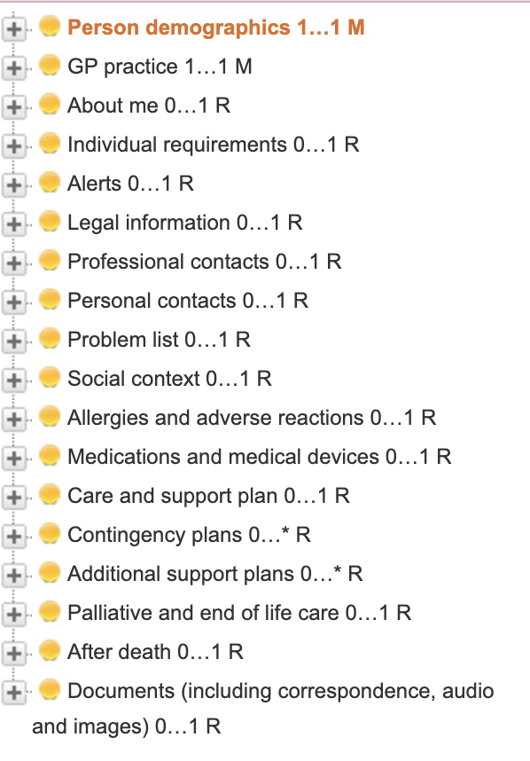

For the full standard see Appendix B.

Out of scope
- Development of (or changes to) supporting technical messages (FHIR profiles or APIs) where they do not already exist – this will be commissioned separately by NHS Digital as required and should include assurance through PRSB by clinical and professional informaticians as identified above.
- Support for piloting and implementation – this could be commissioned as a second . phase.
- Development of any additional supporting plan standards.
- User interface definition for digital systems.

System Definition / Overview
As this Clinical Safety Case report pertains to an information standard rather than a clinical IT system, the systems definition cannot be provided. Multiple systems suppliers will be asked to implement the PEoLC Information Standard and will undertake their own DCB0129 Clinical Safety Case for their individual system.

Clinical Risk Management System
The NHS Digital Clinical Safety Group (CSG) operates a full Clinical Safety Management System (CSMS) that encompasses integration with Health Organisations and professional bodies. The CSMS considers the integration with the Information Standards Board and the process in which professional standards are developed in the CSMS framework. The Clinical Safety Management System has been applied throughout all phases of the PRSB PEoLC Information Standard. This Clinical Safety Case has been developed in accordance with the requirements of DCB0129 Clinical Risk Management: its Application in the Manufacture of Health IT Systems – Specification [Ref. 1] and DCB0160 Clinical Risk Management: its Application in the Deployment and Use of Health IT Systems - Specification [Ref. 2].

The essential structures of a CSMS have been implemented in this project by engagements with the following organisations:

Organisation
Faculty of Public Health
Royal College of Anaesthetists
Royal College of Pathologists
Royal College of Radiologists
Royal College of Surgeons of England
Chartered Society of Physiotherapy
Royal College of Occupational Therapists
Royal College of Speech and Language Therapists
British Dietetic Association
British Psychological Society
Queen’s Nursing Institute
Royal College of Psychiatrists
Royal Pharmaceutical Society
Association of Directors of Adult Social Services
Association of Directors of Children’s Services
Joint GP IT Committee
College of Paramedics
British Geriatrics Society
Royal College of Physicians and Surgeons of Glasgow
Faculty of Intensive Care Medicine
Hospice UK
Sue Ryder
The Good Grief Trust
CRUSE bereavement
The Association of Palliative Medicine
Association of Palliative Care Social Workers

The first step to preventing harm to patients using the PEoLC Information Standard is to ensure a good development process that results in systems which are fit for purpose. Activities that have been carried out to clarify and address this include:

- A Hazard Workshop carried out on the 12th of January 2022, with input from stakeholders and potential users of any such system facilitated by the Clinical Safety Officer.
- Production of a hazard log for the project further revised through consultation with stakeholders.
- Review of the hazard log following online consultation on the standard and any safety risks associated with any of the data item headings within the standard.
- Review of mitigation of risks as part of the development of the standard headings and the implementation guidance.
The Hazard workshop considered the following:
- Review of any hazards or issues that arose during the development of the Palliative and End of Life Care Information Standard.
- Review of existing hazards recorded against the Core Information Standard and previous End of Life Care Standard.
- Consideration and discussion of the new hazards following the updated standard and possible main causes.
- Most likely consequences / potential clinical impact (i.e., for patient safety).
- Mitigations (and recommendations to improve patient safety) leading to a reduced residual risk.
- Clarification regarding actions required and risk transferred to implementers.

Risks were scored using the risk matrix and scoring tools shown in Appendix G.
Hazards that were found to have a residual risk of 3 or more are included in the Clinical Risk Evaluation section.
The suggested mitigations aim to address clinical safety in relation to the design of the structure and description of the content of the standard. Further mitigations will be required when the standard is implemented in clinical / IT systems.
We have flagged some risks relating to implementation in this report but expect that further mitigations will be identified as clinical risk assessments and safety cases are developed by vendors and healthcare organisations during implementation.

Safety organisation structure
Clinical oversight was carried out throughout by Kath Lambert Consultant in Palliative Medicine and Emma Davis GP and Clinical Lead HIOW Shared Care Record as the acting Clinical Safety Officer. The CSO monitored the execution of the Clinical Safety Case and ensure that clinical safety obligations are being discharged in line with the latest Clinical Safety Management policy and processes.

Clinical Risk Analysis
Nine generic and eight PEoLC specific Clinical hazards were identified using the SWIFT (Structured ‘What If’ Technique) method of hazard identification during the hazard workshop. This entailed description of potential hazard, patient safety consequences, explanation of hazard causes, identification of existing controls, an estimation/rating of clinical risk and suggested further mitigations. Potential clinical safety risks and hazards were also explored at regular programme and project meetings. In response to a clinical safety issue raised, relating to version 1.1 of the PEoLC Information standard, an additional generic hazard ‘Legacy data not managed correctly’ was created and one hazard was reassessed as a result of maintenance updates to the standard. During the process of developing, producing and maintaining the PEoLC Information Standard, a total of ten generic hazards (see table 1 below) relating to technical / clinical system functionality and eight clinical hazards were identified.

Generic hazards

Initial | Residual | Risk rating | Definition
0 | 0 | 5 | Unacceptable level of risk.  Mandatory elimination or control to reduce risk to an acceptable level
1 | 0 | 4
4 | 3 | 3 | Undesirable level of risk. Attempts should be made to eliminate or control to reduce risk to an acceptable level. Shall only be acceptable when further risk reduction is impractical.
5 | 7 | 2 | Acceptable where cost of further reduction outweighs benefits gained.
0 | 0 | 1 | Acceptable, no further action required.
Table 1: Summary of PRSB generic hazard risk scores
Of the ten generic hazards, one was scored at level 4 (this hazard was subsequently reassessed and scored 3 as a result of changes to the standard), four at level 3 and five at level 2. Mitigations were applied to all ten hazards, however seven hazards remained the same risk level. The level 4 risk (reassessed at level 3 and mitigated to level 2) and two level 3 risks were reduced to level 2. The level 3 and above generic hazards are further explained in the clinical risk evaluation section.

PEoLC Clinical Hazards
Initial | Residual | Risk rating | Definition
0 | 0 | 5 | Unacceptable level of risk.  Mandatory elimination or control to reduce risk to an acceptable level.
0 | 0 | 4
5 | 1 | 3 | Undesirable level of risk. Attempts should be made to eliminate or control to reduce risk to an acceptable level. Shall only be acceptable when further risk reduction is impractical.
3 | 7 | 2 | Acceptable where cost of further reduction outweighs benefits gained.
0 | 0 | 1 | Acceptable, no further action required.
Table 2: Summary of PEoLC standard clinical hazard risk scores
Of the eight PEoLC specific hazards, five were scored at level 3 and three at level 2, all of which required additional controls to reduce risk to an acceptable level on the Risk Matrix (see table 2 below). After additional controls were put in place 7 were reduced to level 2 - Acceptable where cost of further reduction outweighs benefits gained. The remaining hazard was reduced to level 3 which has an undesirable level of risk. See the clinical risk evaluation section for a summary of the level 3 hazards.
These hazards and their mitigations will need to be reviewed by system vendors developing solutions in this area and healthcare organisations deploying such systems. They will need to consider their own internal clinical safety processes and undertake their own clinical safety checks. This document assists that process but is not a substitute for it. This clinical safety case report is limited in its scope to the standard rather than a functional clinical IT system to which these standards normally apply.
It should be noted that this clinical safety report is necessarily limited in its scope, because it is not directly related to software development or deployment. Suppliers developing software to implement these standards will therefore need to undertake their own DCB0129 Clinical Safety Case and healthcare organisations involved in the deployment of such software will still be expected to apply DCB0160. This clinical safety case report is, however, a useful reference guide for any such projects.

Clinical Risk Evaluation
Nine generic and eight PEoLC Clinical hazards were identified using the SWIFT (Structured ‘What If’ Technique) method of hazard identification during the hazard workshop. This entailed description of potential hazard, patient safety consequences, explanation of hazard causes, identification of existing controls, and estimation/rating of clinical risk and suggested further mitigations.

Hazard Workshop 1 – 12/02/11
Attendees | Role
Emma Davis | Clinical Lead HIOW Shared Care Record, and clinical safety officer for the PEoLC project
Ian Woodburn | Northern Care Alliance NHS FT
Davina Hehir | Compassion in Dying
Dorothy Bean | PRSB Senior Researcher CNIO at NHSE for Southwest Region
Kath Lambert | Project clinical lead, Consultant in Palliative Medicine, Harrogate, and District NHS Foundation Trust
Ed Manning | Data and Intelligence Workstream Lead for Palliative Care and End of Life, NHSE & I
Maria Griffin | PRSB analyst
Malcolm Mundy | PRSB architect
Helene Feger | PRSB project manager/director

Clinical Risk Control
Of the seventeen hazards (both generic and clinical hazards) originally identified, one was scored at level 4, seven at level 3 and nine at level 2. The additional general hazard ‘Legacy data not managed correctly’ was scored at level 3. The level 4 hazard was subsequently reassessed at level 3 following updates to the standard and reduced to level 2. All of the hazards required additional controls to reduce risk to an acceptable level and twelve hazards could not be reduced further. After the additional controls and mitigations were evaluated and verified during the hazard workshops and later identification of a new hazard, and reassessment of the level 4 hazard the residual hazards are:

- Fifteen hazards remained or were reduced to level 2 – Acceptable where cost of further reduction outweighs benefits gained.
- The 3 remaining hazards –remained at level 3 – this is an undesirable level of acceptable risk, and attempts should be made to eliminate or control to reduce risk to an acceptable level. These shall only be acceptable when further risk reduction is impractical.

For the Risk Matrix used see Appendix G.

Below shows a summary of both the generic and clinical hazards that had an initial risk rating of 3 or above (see Generic hazard tab in PEoLC hazard log):

Generic hazards with an initial risk rating of 3 or more:

Generic Hazard number: | 4
Initial risk ranking: | 4 [revised risk ranking after changes to the standard was 3]
Hazard name: | Recording an individual's 'Gender identity' alongside their 'Sex at birth (observed)' in their clinical record and displaying together along with 'Administrative gender' (derived from the Personal Demographics Service) may cause accidental disclosure of transgender, non-binary or gender diverse status individual's consent causing psychological harm.
Hazard description: | Accidental disclosure of gender diverse status, without consent, due to inclusion of the patient's 'Sex at birth (observed)', 'Gender identity' and 'Administrative gender' in the demographics section of a person's clinical record.  For the majority of patients 'Administrative gender' and 'Sex at birth (observed)' will be the same value and no 'Gender identity' will be recorded.
Possible causes: | Display of patient 'Sex at birth (observed)', 'Gender identity' information and 'Administrative gender', in demographics, which do not match e.g. 'Sex at birth (observed)' states 'Male' and 'Gender identity' states 'Female (including trans woman)'.
Potential patient safety impact description: | Potential severe psychological harm to patient and possibly significant others by sensitive information being accidently disclosed without consent. Disclosure adversely affects patient's social wellbeing and support networks.
Mitigation: | Existing controls  Some systems use 'gender' only, in patient demographics, e.g. EMIS, TPP, which means that the record does not indicate a gender diverse status. Likewise, currently the Personal Demographics Service has one data item - Administrative gender. However it is unclear whether the value in these fields is equivalent to a person's 'sex at birth' or 'gender identity', which introduces its own clinical risk for example, in creating cohorts for screening programmes. From a clinical perspective it is important for clinicians to know a person's 'sex at birth' and in some circumstances 'gender identity' along with any gender affirming medications and procedures. Design mitigations  The standard states that Sex and birth (observed) is a mandatory data item, which means it must always be recorded in the clinical record and 'Gender identity' information should only be recorded if a person wants it to be recorded in their record and the clinician decides it is appropriate to do so. The standard states that this information should be shared if it has been recorded (the person has given consent for it to be recorded and shared).  This risk must be mitigated by design of the clinical systems. Entry of gender identity information should be optional and could prompt clinicians to ensure that the patient wants it to be recorded so that it can be shared.Training  Adequate training so staff are competent users of the system.  IG training.  Staff vigilance and audits.  Public engagement with development of local clinical systems.  Business processes  Implement the NHS England IG framework for shared care records. Clarity in national policy regarding the recording of 'Sex at birth (observed)' and 'Gender identity' information in EHRs alongside clarity on use of the relevant data items in the Personal Demographics with due regard for the practical risks posed in clinical practice for patients, practitioners and healthcare providers.
Summary actions/notes: | Accidental disclosure of gender diverse status, without consent, due to inclusion of the patient's 'Sex at birth (observed)', 'Gender identity' and 'Administrative gender' in the demographics section of a person's clinical record.  For the majority of patients 'Administrative gender' and 'Sex at birth (observed)' will be the same value and no 'Gender identity' will be recorded.  The standard states that 'Sex at birth (observed)' is a mandatory data item, which means it must always be recorded in the clinical record and 'Gender identity' information should only be recorded if a person wants it to be recorded in their record and the clinician decides it is appropriate to do so. The standard states that this information should be shared if it has been recorded (the person has given consent for it to be recorded and shared).  This risk must be mitigated by design of the clinical systems. Entry of gender identity information should be optional and could prompt clinicians to ensure that the patient wants it to be recorded so that it can be shared.  It is unlawful to disclose, without consent, a person's gender reassignment with or without a gender reassignment certificate. The inclusion of both 'sex/ phenotypic sex and gender in the patient's demographic's section may inadvertently result in disclosure.  The information model is a set of information that people want to share.  This risk must be mitigated in the implementation of the standards in any clinical system. This can be done by only including "Gender" or by ensuring the design of the clinical system including its Information Governance model reduces this risk to an acceptable level. PRSB to include this requirement in the Implementation guidance document that+Q6 accompanies the standard.
Residual risk: | 3 [reduced to 2 following reassessment and mitigation]

Generic Hazard Number: | 2
Initial risk ranking: | 3
Hazard name: | Healthcare professional or team delivers incorrect clinical care to an individual due to missing or incorrect clinical information.
Hazard description: | Data in source system is of poor quality. It is incomplete, incorrect, out of date or inconsistent. For example, a DNACPR decision that is not updated in a single system could be recorded in several systems and could be inconsistent. In addition there may be paper documents with conflicting information.
Hazard causes: | 1) Data is not updated in the source systems and therefore becomes out of date and contradictory.  2) Lack of context and provenance of data items may make them appear contradictory.  3) Inconsistent recording of information across different systems e.g. different entries for severity of disease on same day.  4) Incorrect data entered into the source system due to lack of controls e.g. data entered for incorrect patient.  5) Data processing and de-duplication results in removal of important data items.  6) Lack of training in data quality and good electronic record keeping.  7) Medications not up to date and immediate therapeutic interventions that have taken place are lost to the record for example, because of handwritten changes may be made to the printed medicine administration record by the GP.  8) Due to the transient nature of some conditions e.g. pregnancy, there could be issues updating the information on which these run to ensure it is current or the information may be missing.  9) Mandatory fields may adversely affect data quality especially if they are linked to KPIs.  10) Data such as that about child protection retained into adulthood when it no longer applies  11) Data retained in the source system beyond time limit.  12) The standards do not take account of time limited data.
Potential patient safety impact description: | Psychological harm to patient and possibly significant others by confidential data being shared inappropriately beyond its expiry date
Mitigation: | Existing controls / Mitigation  Access to current local system data sources retained.  Normal/ usual professional. practice and accountability.  Design mitigations  Source and receiving systems should conform with the latest version of the standard and ensure local modifications do not impact them.  Only use SNOMED CT in communications (e.g. not READ, OPCS etc,) with appropriate use of value sets and constraints  The context and provenance of transferred data is clear and retained by receiving systems.  Source systems should manage time limitations for appropriate data items.  Test  End to end clinical testing by implementers.  Training  Training in data entry and sharing in local system.  Business process controls  Ensure there are clear robust methods for updating and correcting the clinical systems.  Ensure stakeholders, including patients/ service users know how to get the record corrected and/ or updated as required.  Ensure stakeholders know who holds responsibility for the integrity and maintenance of the record and the process of accountability.  National adoption of SNOMED CT.  Ensure contributing systems can record coded structured data mapping to the standard where possible.
Summary of actions / Notes: | 1) Normalisation rules need to be developed with clinical oversight.  2) Communications will only support SNOMED CT.  3) Guidance provided to implementers.  4) Residual risk transferred (with guidance) to implementers.  5) Cross boundary implementation matter.  6) Descriptions to travel with concept IDs.  7) Developers to be aware of retention requirements of time limited data.
Residual risk: | 3

Generic Hazard Number: | 3
Initial risk ranking: | 3
Hazard name: | Partial or incorrect information shared by organisations with clinicians and patients may be interpreted incorrectly causing physical and / or psychological harm to the patient.  Information shared by other organisation with other clinicians or patients may be difficult to understand/interpret causing psychological harm.
Hazard description: | Critical data in the system is hard to locate, missed, misinterpreted or represented incorrectly.  Where the record is shared with the patient information may be difficult to understand/interpret by patient.
Hazard causes: | 1) Healthcare professional assumes their system contains all the clinical data available.  2) Unclear which sections should contain specific information e.g. observations and investigations results and therefore it may not be presented where a healthcare professional expects to see it on the screen and what the sections or elements mean e.g. misinterpretation of ‘acute’ verses repeat prescription medications in system- acute has no end date so the system interprets it as ongoing medication.  3) The standards are complex and are misunderstood and therefore not correctly implemented.  4) The data may have been entered into the wrong section of the record by mistake e.g. Reasonable adjustments or allergy information inappropriately included in the About Me, or not correctly populated.  5) Blank fields may be misinterpreted. There is a lack of clarity over what a blank field signifies (i.e. not recorded, not assessed, not present, etc).  6) Multiple different systems and data structures, semantics and language and processes across different settings and users which may lead to incorrect interpretation / translation of clinical information  7) When using diagnosis qualifiers to indicate the certainty of a diagnosis, separation of diagnosis qualifier from diagnosis SNOMED CT code – Data is sent as post-coordinated terms and the receiving system cannot interpret this.  8) Data badly presented in the system (GUI).  9) End user not able to use the system effectively potentially through lack of training. 10) Information not found because of volume of data / information overload – critical data such as significant problems or allergies could be missed, and a lack of metadata may restrict searching and views.  11) Losing the link to a source document, for example the discharge summary means the context is lost.  12) Inability to determine where, when and by whom clinical information was recorded means the context is lost.  13) Clinicians unclear about the purpose of some of the information e.g. in About Me.  14) Sections with unstructured data such as ‘About Me’ or ‘problem list’ not be easily found in searches and therefore not reviewed in a timely manner.  15) Alerts are not viewed because professionals are unaware where to look for them or are used to pop-ups.  16) Unfamiliar context/terminology to patients/ service users used in populating the information.
Potential patient safety impact description: | Healthcare professional delivers inappropriate care due to missing or incorrectly interpreted clinical information.  Patient / service user / carer is unable to interpret the data due to it being incomplete and may fail to engage with healthcare professionals or team. Patient is not empowered to self-care and participate in their care. Resulting in psychological and physical harm.
Mitigation: | Existing controls / Mitigation  Access to current local system data sources retained.  Normal/ usual professional. Practice and accountability.  Design mitigations  Usable design of clinical systems.  Source and receiving systems should adhere to the standard and ensure local modifications do not impact them.  End user engagement in design.  Mitigated by design of the standards through multi professional consultation to address whether sections (and definitions) match those used by / needed by end users.  Test  End to end clinical testing by implementers.  Training  Good professional practice and understanding of digital record use.  Education in understanding of the different professions’ roles and language semantics.  Understanding of and training/ education in shared digital record use – especially understanding the structure and purpose of the About Me section.  Training end users of systems to understand the source of the data and the importance of context to support judging the validity of an entry.  Education and training in standards medication management and medication reconciliation.  Education about how information is going to be shared and used.  User education and training to keep the source information updated.  Professional accountability – check status with patient.  Understanding of and training in alerts and their usage.  Training and education in using ‘plain English’.  Training to understand that a blank field may not mean there is no data. That the person is not pregnant, does not drive, does not smoke etc.  Business process controls  Ensure there are clear robust methods for updating and correcting the information.  Ensure stakeholders, including patients/ service users know how to get the record corrected and/ or updated as required.  Ensure stakeholders know who holds responsibility for the integrity and maintenance of the record and the process of accountability.  Ensure stakeholders know the purpose of the About Me standard as defined in the About Me implementation guidance.
Summary of actions / Notes: | 1) The business processes to query and update data needs to be defined.  2) Sections to be clearly defined.  3) System design – there is an expectation that clinical systems suppliers will develop views of the data to enable better understanding of the context and provenance of the information.  4) Professional accountability.  5) Audit, exception management and record curation.  6) The people using these sections need to be trained to use them, including semantics of language.  7) Guidance provided to Implementers (to include retention of context/provenance).  8) There is still significant work to agree what the “Problem List” section will contain and how it is updated and curated.  9) Clarity required on whether pregnancy status is an imported or calculated value.  8) Residual risk transferred (with guidance) to implementers.
Residual risk: | 2

Generic hazard number: | 7
Initial risk ranking: | 3
Hazard name: | Clinicians and other health and social care end users failing to adopt the PEoLC standard when recording PEoLC information about an individual leading to suboptimal, delayed, or inappropriate patient care.
Hazard description: | Service providers may lack awareness of the standard or systems suppliers may not meet minimum conformance standards to implement the standards.
Hazard causes: | 1) Confusion across the system about whether the standard is mandated and the role and importance of the standard.  2) Providers and suppliers prioritising secondary uses services DCB standards over PRSB standards because they have ISN status.  3) Misalignment of PRSB standards and related DCB standards leading to difficulties with implementation.  4) Lack of co-ordination and common approach between the different elements in the system.  5) Heterogeneity in the data items recorded by different systems in different care settings which may mean that certain settings consider the scope of the standards as limited or difficult to implement.
Potential patient safety impact description: | Failure to share information between systems means that healthcare professional may not have all the information they need to support clinical decision making resulting in inappropriate care or psychological and physical harm to the patient.
Mitigation: | Existing controls / Mitigation  The development of PRSB standards involve Data Dictionary and SNOMED CT terminologists.  Health and care professionals, patients and systems suppliers are involved in the design of the standards.  Levers and incentives in place to use nationally approved codes e.g., GP contract, NHS contract, relevant ISNs; NHSD implementation programmes encourage adoption of the standards such as assurance via the DAPB process.  Design mitigations  Effective design of clinical systems  Clarity, from the centre, about the role and importance of implementing the standard.  National levers and incentives to adopt the standard.  Test  End to end clinical testing.  Training  Understanding of and training/ education in shared care record use.  IT commissioners and system developers educated and trained in the importance of clinical standards.  Business process controls  National levers and incentives to adopt the standard,  see notes in ‘Summary of actions / notes’ section of this document.  National adoption of SNOMED CT.
Summary of actions/ Notes: | 1) Communication of the benefits of adopting the standards by NHS Digital, NHS England, PRSB, bodies.  2) Transfer of responsibility to clinical systems owners via completion of DCB0160.  3) Championing by stakeholder organisations who have provided endorsement for the standards.
Residual risk: | 3

Generic hazard number: | 10
Initial risk ranking: | 3
Hazard name: | Legacy data not managed correctly.
Hazard description: | When implementing the standard in active systems legacy data (in particular regarding the CPR decision) is not migrated into the End of Life template.
Hazard causes: | 1) Concepts other than those defined in the standard were used prior to implementing the standard.  2) Previous CPR decision concepts or decisions were not presented to the user.  3) Due to data migration issues a blank field is presented to the user.
Potential patient safety impact description: | An incorrect decision regarding CPR is made. To give CPR against the patient wishes or to not give CPR when the patient wished to be resuscitated.
Mitigation: | Existing controls / Mitigation  Current good clinical practice would be to review a patient’s resuscitation status at regular intervals – particularly at time of change in health. Resuscitation status should therefore be regularly checked with the patient and the patient’s carers.  Resuscitation wishes are recorded using paper forms held in the patients place of residence. IT system recording would not automatically overwrite these.  Good system design would display the legacy data appropriate when a new data entry field is presented.  Design mitigations  Data migration must be considered when implementing the standard  Presentation of legacy data adjacent to the new data entry fields  migration of legacy data to the new forms when appropriate.  Test  Validation that legacy data is maintained and displayed.  Training  Users should be updating the CPR decision regularly - validating with patients and patient's carers.  Business process controls  User should be updating the CPR decision regularly - validating with patients and patient's carers.
Summary of Actions / Notes: | 1) Suppliers and implementers need to address legacy data when implementing the standard.  2) Existing data in system which is pertinent to end of life needs to be migrated into the new standard.
Residual risk: | 2

PEoLC specific hazards with an initial risk rating of 3 or more (see PEoLC tab in PEoLC hazard log):

PEoLC clinical hazard number: | 1
Initial risk ranking: | 3
Hazard name: | A patient’s legally binding information (ADRT & LPA) is not sighted by appropriate clinical/medical staff meaning patients may not get the care according to their previously stated preferences or patient’s wishes not being met leading to possible physical and / or psychological harm.
Hazard description: | Clinicians and other staff cannot access the patient’s legally binding information as required.
Hazard causes: | 1) Lack of understanding about medicolegal issues.  2) Not being able to locate the original document.  3) Attached legal document out of date.  4) Different statutory and legal requirements across the four UK countries that may lead to confusion by clinicians about which sections are relevant to the country in which they work.
Potential patient safety impact description: | The patient may not get the care needed. For example, if a patient has an 'Advanced Decision to Refuse Treatment' order then their rights may not be met if the information is not available to staff caring for them resulting in physical or psychological harm.
Mitigation: | Existing controls / Mitigation  Include requirement for sections in system procurement and configuration. Test that the system can support the sections. Standards development included professionals and patient representatives on stakeholder groups.  Design mitigations  Mitigated by design to ensure access to the original documents is possible.  Test  End to end clinical testing by implementers.  Training  Training on medicolegal and country specific issues.  Business process controls  Processes in place to ensure the original legal documents can be viewed and mechanisms to ensure these are up to date.
Summary of actions/ Notes: | National solutions are currently being sought to this problem.
Residual risk: | 3

PEoLC clinical hazard number: | 3
Initial risk ranking: | 3
Hazard name: | Incorrect or conflicting information that does not provide the full picture may result in incorrect decision making or lack of support for patients leading to physical and / or psychological harm.  Medical /clinical /other staff leading to not being able to see or share contextual and significant information including priorities of care for end-of-life patients.
Hazard description: | The most important information must be available in a manner that supports decisions making. This includes priorities of care and contextual information that is presented at the appropriate stage of care interventions.
Hazard causes: | 1) There could be issues where the full holistic data about the patient is not captured.  2) Partial or incomplete information could be misunderstood. 3) Incomplete data or limited data items are shared.
Potential patient safety impact description: | Incorrect or conflicting information that does not provide the full picture may result in incorrect decision making or lack of support for patients resulting in psychological and/ or physical harm.
Mitigation: | Existing controls / Mitigation  Include requirement for sections in system procurement and configuration. Test that the system can support the sections. Standards development included professionals and patient representatives on stakeholder groups.  Design mitigations  Design of shared care record system and logical data model (out of scope).  End user engagement in design (out of scope).  Clarity, from the Centre, about the role and importance of implementing the standard.  National levers and incentives to adopt the standard,  see notes in column Q.  Test  End to end clinical testing by implementers.  Training  Understanding of and training/ education in shared care record use.  IT commissioners and system developers educated and trained in the importance of clinical standards.  Business process controls  Ensure stakeholders know the purpose of the About Me standard as defined in the About Me implementation guidance.  Ensure discussions take place that capture the patients’ and carers’ priorities and wishes about the end-of-life care.  Transfer of responsibility to clinical systems owners.  Owners to meet the expectations of Clinical Safety DCB0160.
Summary of actions/ Notes:
Residual risk: | 2

PEoLC clinical hazard number: | 4
Initial risk ranking: | 3
Hazard name: | Palliative and End of Life information about an individual that is available is not acted upon by medical /clinical /other staff.
Hazard description: | Medical or clinical staff may not act upon the information that is available or trust the value of the information resulting in the patient receiving inappropriate care causing physical and/or psychological harm to the patient.
Hazard causes: | 1) Information model in source system is misinterpreted/ not understood. e.g. Details in About Me are not considered relevant  2) Local Protocols may override patients’ wishes.  3) Sections have similar meanings so users are unsure where to find the information they need e.g. About Me, Individual Requirements and Social Context.  4) Semantics and language difference between the different professions such as local authority or between patients and care providers.  5) The Palliative and End of Life Care information standard model is inconsistent.  6) Multiple different systems and data structures, for example local authorities and care homes, which may lead to incorrect interpretation / translation of clinical information - including across boundaries.  7) Inconsistent use of sections due to events such as inconsistencies in data transfer between different systems; such as between different organisations of the same domain e.g. between different local authorities or between different care homes or between organisations of different domains e.g. between care homes and local authorities.
Potential patient safety impact description: | Organisational protocols may be in place that do not align with the patient’s wishes or staff may revert to preferred practice resulting in information not being acted upon which may cause death or permanent life-changing incapacity; severe injury or severe incapacity from which recovery is not expected in the short term.
Mitigation: | Existing controls / Mitigation  Design of shared care record system and logical data model (out of scope).  Contributing systems should adhere to the standard and ensure local modifications do not impact them (out of scope).  End user engagement in design (out of scope).  Mitigated By Design. Multi-professional consultation (including local authority and care home stakeholders) to address whether sections (and definitions) match those used by / needed by end users. Ensuring the design of shared care record system can handle the local authority data model (out of scope) - (LA information).  Design mitigations  Design systems to support initiatives that align to national or local workstreams.  Test  End to end clinical testing by implementers.  Training  Good professional practice and understanding the importance of the information standard data in shared care record use.  Business process controls  Review the processes in place for using the data and audit how decisions are made. Ensure stakeholders know who holds responsibility for the integrity and maintenance of the record and the process of accountability.
Summary of actions/ Notes:
Residual risk: | 2

PEoLC clinical hazard number: | 5
Initial risk ranking: | 3
Hazard name: | Those at their end of life are not identified in a timely and comprehensive manner resulting in a delay to care and adherence to their end of life wishes resulting in psychological and / or physical harm.
Hazard description: | There is a need to improve how people at the end of their life are identified and thus offered the appropriate care. Many people are not identified until very near death. Patient is therefore unable to be involved in discussion and decision making around end-of-life care and no information is recorded.
Hazard causes: | 1) Many patients present very late with life ending conditions.  2) There may be a lack of local processes that identify end of life patients.
Potential patient safety impact description: | The standard is introduced to improve the care of people with Palliative and End of Life care needs. However, if people are not identified at end of life, then the standard will not be implemented as required resulting in psychological and or physical harm and maybe a poor experience of death and dying.
Mitigation: | Existing controls / Mitigation  None.  Design mitigations  Design systems to support initiatives that align to national or local workstreams.  Test  N/A.  Training  Training/ education.  Business process controls  National policy to support levers that help better identify end of life patients.
Summary of actions/ Notes:
Residual risk: | 2

PEoLC clinical hazard number: | 8
Initial risk ranking: | 3
Hazard name: | Patients / and/or significant others accidentally becoming aware of their or their loved one’s end of life prognosis without having had a discussion with a clinician causing psychological harm.
Hazard description: | Differences in managing patient’s awareness of their end-of-life prognosis may mean disclosure of information that can cause considerable upset, is sensitive and not welcomed by the patient.
Hazard causes: | 1) Results being added to record, which is visible to the individual or significant other before being informed by their clinician.  2) Data contains information that a patient may not be aware of or indeed wish to see.  3) Prospective full record access to GP records for patients where a GP Practice has not carried out review of appropriateness to share information direct with the patient or proxy.
Potential patient safety impact description: | Psychological harm to patient and possibly significant others by sensitive information being shared that patient/ service user did not want shared. Can adversely affect a patient's wellbeing.
Mitigation: | Existing controls / Mitigation  Professional accountability and training in good record keeping.  Design mitigations  Design of shared care record system and logical data model (out of scope).  Only posting data when it is reviewed.  Mechanisms for patients to know who and how to make contact for support.  Mechanisms for identifying and redacting third party information.  Test  End to end testing by implementers.  End to end testing to include patients.  Training  Staff training in difficult conversation and in understanding patient preferences.  GP Practices prospective record access training.  Business process controls  Review the processes in place for using the data and audit how decisions are made.  Ensure stakeholders know who holds responsibility for the integrity and maintenance of the record and the process of accountability.  Ensure there are clear robust methods for updating and correcting the information.  Ensure stakeholders, including patients/ service users know how to get the record corrected and/ or updated as required.  N/A
Summary of actions/ Notes:
Residual risk: | 2

Hazard Log

The Palliative Care and End of Life Care Information Standard hazard log is embedded below and available for download from the PRSB website here.

Please note: The mitigations we have taken to address clinical safety risks are largely in relation to the transmission of data between software suppliers’ systems. Further mitigations will be required when the headings are implemented in electronic health record systems. We have flagged some risks relating to implementation in this report but expect that further mitigations will be identified as clinical risk assessments and safety cases are developed by vendors and sites during the implementation.

Test Issues
As this Clinical Safety Case report pertains to an information standard rather than a clinical IT system, live testing was not undertaken.

Summary Safety Statement
The clinical safety statement is based on the safety argument below, based on two of the following criteria: -

- Demonstration of adherence to a fit for purpose clinical safety process:
The Clinical Safety process described in Section 4 has been carried out and is consistent with NHS Digital’s Clinical Safety Management System (CSMS) and DCB 0129 outlined in reference 1.
- The mitigation is deemed to be appropriate and commensurate with the scale of risk. Risk is deemed to be acceptable in most cases and tolerable in others.
All risks identified within the hazard log have been managed via their associated controls to either an ‘Acceptable’ or ‘Tolerable’ level, in line with the identified risk tolerance levels. It should be noted that the acceptability of residual risk is dependent on implementation of the recommended controls identified in the hazard log. If these controls are not deployed, the increased level of risk could result in disruption and delay to patient care.

As previously stated, this clinical safety report is not directly related to software development or deployment. It has been designed to look at the clinical safety hazards and mitigate the risks in the creation and production of the PEoLC Information Standard itself. Suppliers developing software to implement the standard, will therefore need to undertake their own DCB0129 Clinical Safety Case and healthcare organisations involved in the deployment of such software will still be expected to apply DCB0160.

From this perspective the Clinical Safety Officer considers the Palliative and End of Life Care Information Standard v1.11 safe to deploy.

Quality Assurance and Document Approval
All PRSB standards and associated documents undergo a formal internal assurance process and full approval by the board before any standard is released for public use.

Configuration Control / Management
Future governance of the development and maintenance of the PEoLC Information Standard is the responsibility of the PRSB.

All reviews and changes are fully documented and recorded via the version control processes within the software hosting the PEoLC Information Standard.

Appendices

Appendix A – Palliative and End of Life Care Working Group Members

Organisation | Role
NHS England and Improvement | Covid-PEoLC Response Team member
Harrogate and District NHS Foundation Trust | Consultant in Palliative Medicine
NHS England and Improvement Personalised Care Coproduction Group | Person with lived experience
NHS England and Improvement Personalised Care Coproduction Group | Person with lived experience
NHS England and Improvement | Project Manager Personalised Care (Palliative and End of life)
NHS Digital | Senior Clinical Business and informatics Lead. (Occupational Therapist) & Clinical Safety Office
Public Health England | Analytical Programme Manager (NEoLCIN)
Public Health England | Public health intelligence analyst
NHS South Cheshire CCG | GP, Clinical Director, and Lead for end-of-life care
Compassion in Dying | Director of Partnerships and Information
Collingwood Surgery | GP Clinical Lead for Palliative Care
Professional Records Standards Board | Chief Executive
Professional Records Standards Board | Senior Analyst
North London Hospice | Medical Director and Consultant in Palliative Medicine
Marie Currie West Midlands Hospice | Consultant in Palliative Medicine and Medical Director
Hospice UK | Head of Learning and Workforce
Together for Short Lives | Head of Public Affairs and Policy
Kings College London | Palliative care consultant
University of Leeds | Researcher - NIHR EPaCCS
The Royal Marsden | Palliative Care Consultant

Appendix B - PEoLC Information Standard

https://theprsb.org/standards/palliativeandendoflifecare/
Navigate to ‘View the standard’

Appendix C – PEoLC Information Standard – Final Report

https://theprsb.org/standards/palliativeandendoflifecare/
Navigate to ‘supporting documentation’ – Final Report

Appendix D - PEoLC Survey Report

https://theprsb.org/standards/palliativeandendoflifecare/
Navigate to ‘supporting documentation’ – Survey Report

Appendix E - General implementation guidance for ALL PRSB standards
https://theprsb.org/standards/palliativeandendoflifecare/
Navigate to ‘supporting documentation’ – Implementation Guidance

Appendix F - Link to the PRSB PEoLC Information Standard web page
https://theprsb.org/standards/palliativeandendoflifecare/
Navigate to ‘supporting documentation’

Appendix G – Risk scoring Matrix
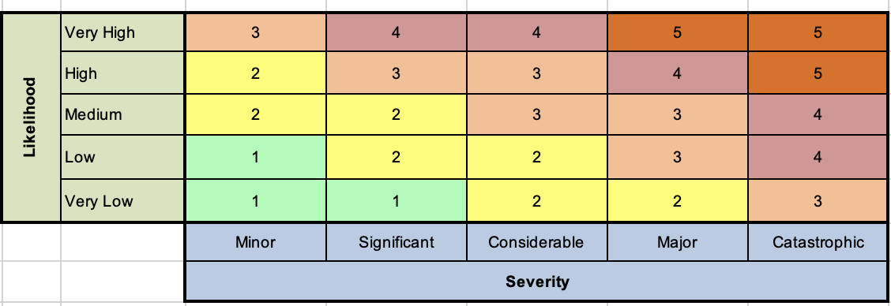
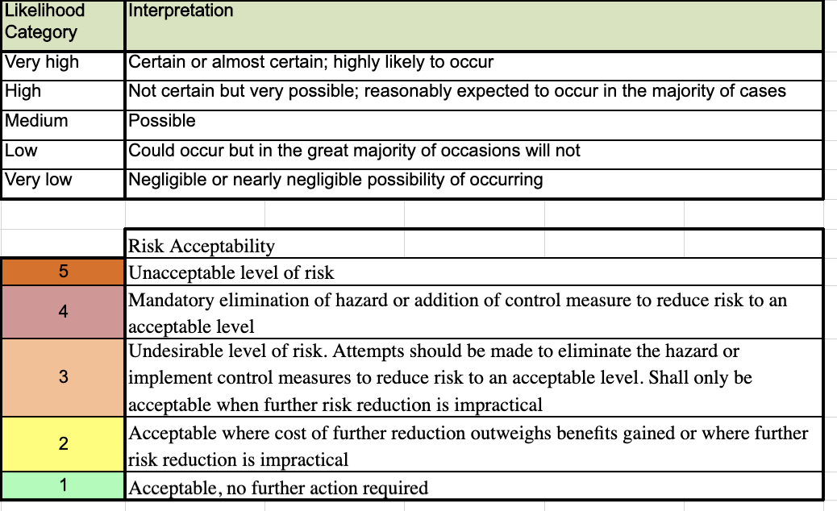

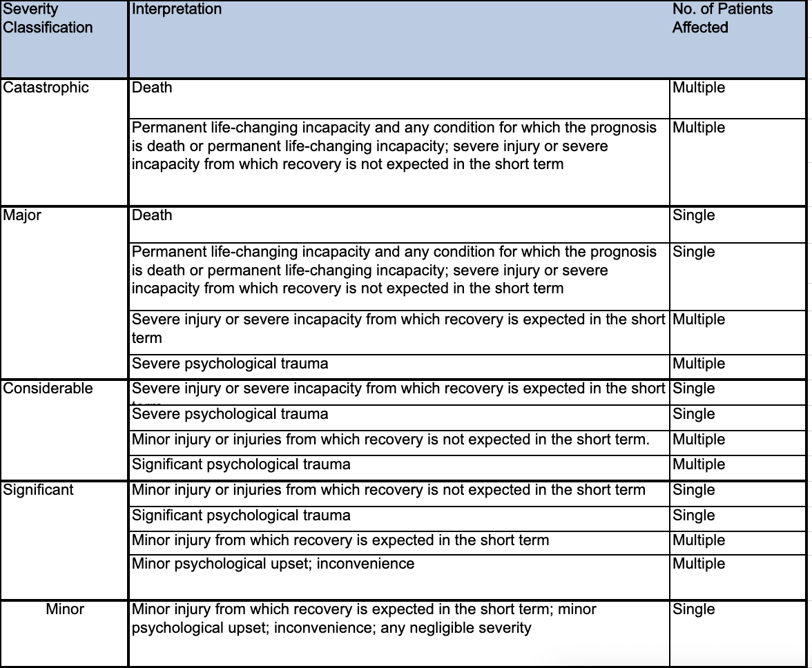

Likelihood Category | Interpretation
Very high | Certain or almost certain; highly likely to occur
High | Not certain but very possible; reasonably expected to occur in most cases
Medium | Possible
Low | Could occur but in the great majority of occasions will not
Very low | Negligible or nearly negligible possibility of occurring

